BINH MY 2 PRIMARY SCHOOL
Grade 4
UNIT 9: What’s the fastest animal in the world? (lesson one )
- Look and circle the correctwords:
  - The movie theater is very deep /high.
  - The lake is very wide /tall.
  - The Pacific waterfall / Ocean is the widest ocean in theworld.
  - Everest is the highest mountain / ocean in theworld.

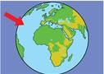
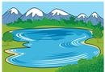
- Write thewords:

1. 2. 3.


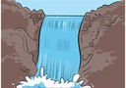
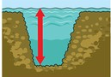
4. 5. 6.

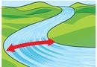
7.

The end

